

**Muhammad Raimi bin Rozainor**

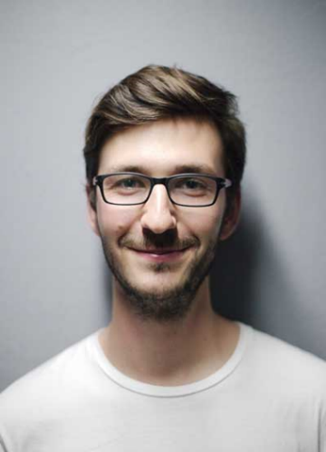

**LANGUAGES**

* Bahasa Malaysia
* English

**LANGUAGES**

* **Bahasa Malaysia**

Spoken

Written

Listen

* **English**

Spoken

Written

Listen

**PERSONAL SKILLS**

|  |
| --- |
| * Hardworking |
| * Teamwork |
| * Communication * Leadership |

**SKILLS**

|  |
| --- |
| * Microsoft Word |
| * Microsoft Excel |
| * Microsoft PowerPoint * Microsoft Access |

**ABOUT ME**

Brings structure and teamwork into every task handled. Balances clarity, communication, and decision-making to ensure smooth progress. Enjoys seeing plans turn into results through shared effort and clear steps. Maintains energy during tight deadlines and changing priorities. Adjusts quickly without losing direction. Constantly looks for better ways to handle work and support those around.

**EDUCATION**

**Nilai Harta Consultant Sdn. Bhd.**

29 Sep 2020 – Current

Pembantu Penilai, Agensi Hartanah

**Combat Electrical Engineering Sdn. Bhd.**

24 May 2019 – 24 December 2019

Pembantu Chargeman, Penyelia

**Better Power Sdn. Bhd.**

15 June 2017 – 15 April 2018

Penyelia Talian, Operator Mesin

**Institut Kemahiran MARA Kuala Lumpur**

2019 – 2020

Diploma Kompetensi Elektrik A4

**Kolej Kemahiran Tinggi Mara Pasir Mas**

2015 – 2018

Diploma Kejuruteraan Elektrik Kuasa

**Royal Military College**

2013 – 2014

Sijil Pelajaran Malaysia

**EXPERIENCE**

**REFERENCE**

**REFRF REFERFRFFERFREFREFER**

ERFERFREFERFRFERFRF

EFERFERFRRFRF

REFERFRRFER

**REFERFERFERFEFE**

REFERFERFERFERFER

REFERFERFERFERFE

ERFERFERFERFRE



ADDREEEEEEEEEEESSSSSS

PHONEEEEEEEEEE

EMAILLLLLLLLLL